
Alstonville RSL Sub-Branch

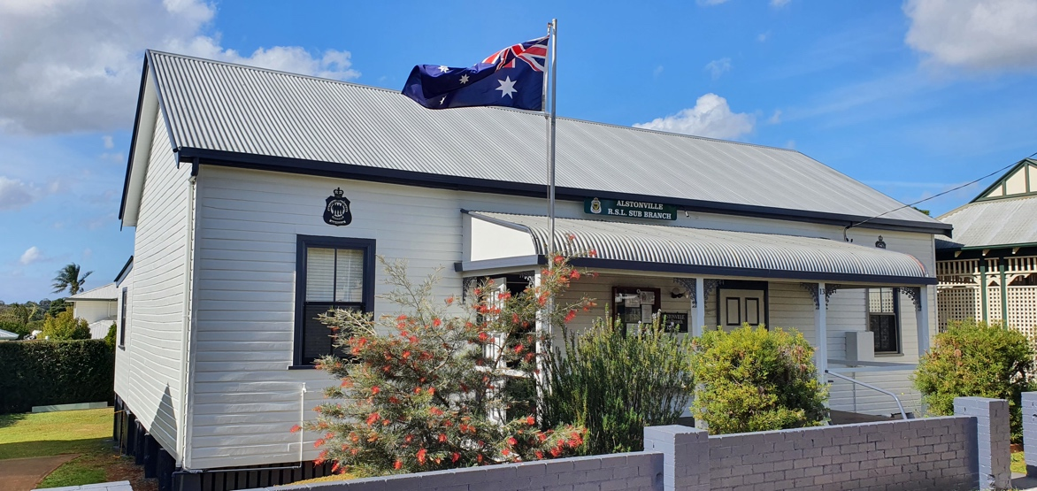
  Standfast 2026
    - Issue 300
    - August 2026
FOR YOUR DIARY:
Next Sub-Branch meeting Saturday 11th September 2026
@ 11.00am
13 Budgen Avenue
Alstonville NSW 2477
Email: AlstonvilleSB@rslnsw.org.au
www.alstonvillerslsubbranch.org.au
PHONE/FAX 02 6628 6156
PO Box 692 ALSTONVILLE NSW 2477
Alstonville RSL Sub-Branch Office Bearers
President | John Porter | 0477773140  0437509790 | All emails to:
Vice President | Phil Skinner | 0427291292 | AlstonvilleSB@rslnsw.org.au  jonportrsl@gmail.com
Vice President | Steve Bryce | 0427202384
Secretary  Treasurer | John Porter  Gary Henderson - Smith | 0437509790  0400474413



Dear Members
Spring is in the air. Winter was mild but wet. Most of us got a cold or virus which is normal for this time of the year.
I attended the FNCDC meeting held at Casino RSM Club on the 23 August 2026. Brig Vince Williams President of the RSL NSW and Jye Martyn from the Hunter Newcastle CRP were present.
Vince discussed with us the future of the RSL NSW and its new directions. He spoke about the VSF Veterans Support Fund and Sport & Recreation Fund. He gave us ideas on how to fund initiatives moving forward.
John Gordon resigned as the FNCDC Honorary Secretary.
I was re-elected as the new FNCDC President.
I held a meeting with RSL Life Care in Tweed during the month. Their official opening is next month. I mentioned to Michael McGovern Manager, that we would be directing our members towards the new Hub for Advocacy. I must admit the new hub is very impressive. Jim Yeo wanted to move in. LOL
As I mentioned, the portico is going to get its final touches this month. Furthermore, the back storage shed is getting a face lift. A new paint job..
I need to apologize for not being at our next Committee and Members meetings. I’m off to Asia with Margy for two weeks.
We commemorated three significant events during this month. Held at EAB Park on the 18^{th of} August, we honor those who fought in the Pacific Campaign, along with Vietnam Veterans Day and lastly the 6oth Anniversary of Long Tan. Around 12-14 people attended the service. Thank you for your service. You have all served your country proudly.
Lest We Forget!!
I would like to thank Hyphen for organizing the fitment of the exhaust fan in the kitchen hall. Green Valley Electrical owner Andy Conan donated the fan and fitment free of charge. Thank you very much for your donation.
Blessings !!
John Porter
President

From the President

MINUTES of the sub-Branch General Meeting dated 08th August 2026
Chairman: John Porter declared the meeting open at 11:07am with the wreath laid by VP Phil Skinner followed by the Ode and a half minutes silence.
Attendance was 22 with 7 apologies
MOTION – Those apologies be accepted
Moved – Steve Bryce Second – Phil Skinner
CARRIED
Minutes of the Meeting held on 11th July 2026
MOTION - That the Minutes of the meeting on 11th July 2026, as printed, be accepted as a true record of that meeting.
Moved - Hyphen Seconded – Bob Wilson CARRIED
Business arising from minutes – Nil business arising

Correspondence
Inwards Nothing to report
President read the received and sent correspondence including:
State circulars
MOTION – That the inwards correspondence be adopted, and the Outwards correspondence be endorsed.
Moved – John Porter Seconded – Phil Skinner CARRIED

Treasurers Report
The treasurer presented the Revenue statements and accounts as at 31 July 2026 and the Accounts for payment.

MOTION – That the Revenue Statement as at 31 July 2026 be accepted, and the Payment of Accounts for June/July be approved.

Moved – Garry Henderson Smith Seconded – Tony Tyler CARRIED

State HQ – Nothing to report
FNCDC – The FNCDC Meeting 23 August 2026
Welfare & Hospital visits – Last week we had 2 patients to visit
Hall Bookings- No changes
Membership – Membership is now 75
Memorabilia- No change
Fundraising – Nothing to report

General Business
Front hall portico is nearing finalization. Over this coming month the tradies are coming to complete. Thanks to Steve Bryce who removed the vines and debris from our rear yard storage shed. Yes, it is going to be painted!!
Veteran & Family Sunday afternoon BBQ games and movies. Combined with Astronomy Club in August was cancelled.
Re-Election of Gary Henderson-Smith as Treasurer.
Resignation of Secretary – John Gordon accepted by President & Members.
We have a new Facebook Ad on local pages promoting our Sub branch openings on Tuesday & Friday. See the Advertisement in the back of this report.

Birthday Wishes
Happy 80th Birthday Harry


Sub-Branch Meeting Minutes

Good News Story By Hyphen
Among the additions to the hall recently, we have had an exhaust fan installed in the kitchen. I was chasing around for quotes to do this job and came across Green Valley Electrical. The company owner Andy met me at the hall to check out the job and true to his word called me with his “quote” a few days later. His price was a sincere thanks for your service, to all at the hall. Andy said that he was aware of the help we gave to veterans in the area. He then proceeded to supply and install the fan as we requested completely at his own expense.
I have always said that we should support those local businesses that support us, so if you require any electrical jobs, I suggest you give Andy a call. He’s local, very reliable and efficient, as well as being a nice bloke.

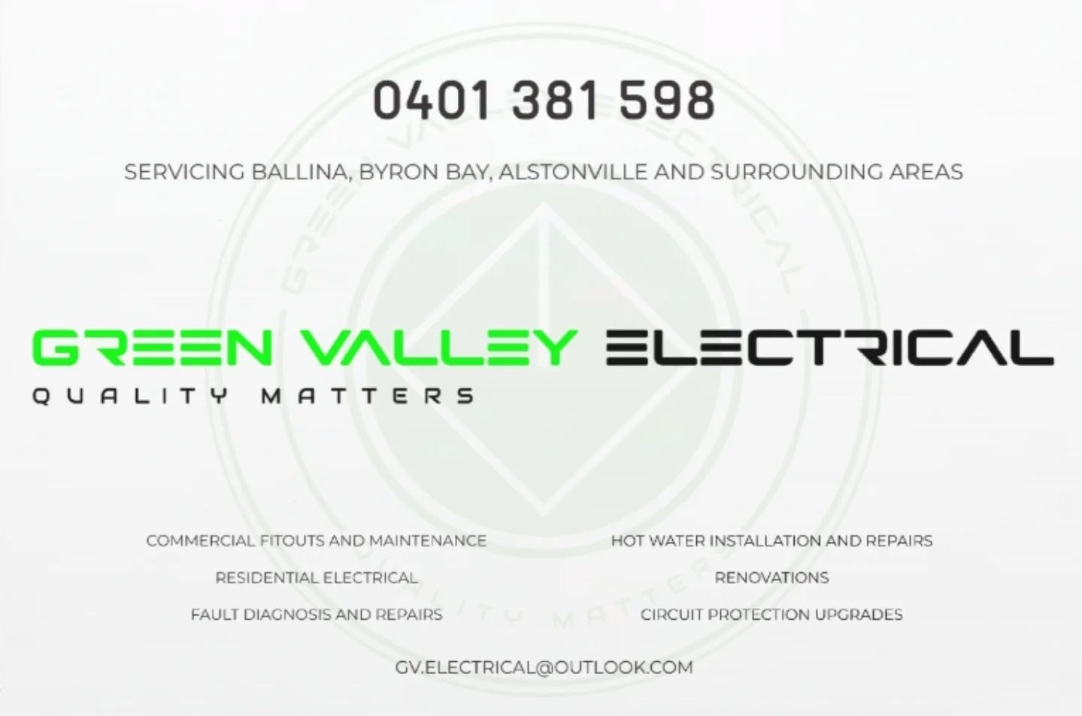

NOTICE BOARD

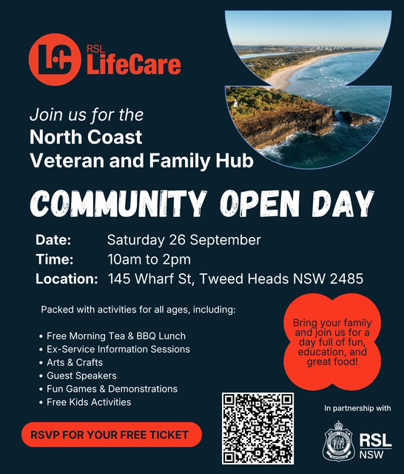
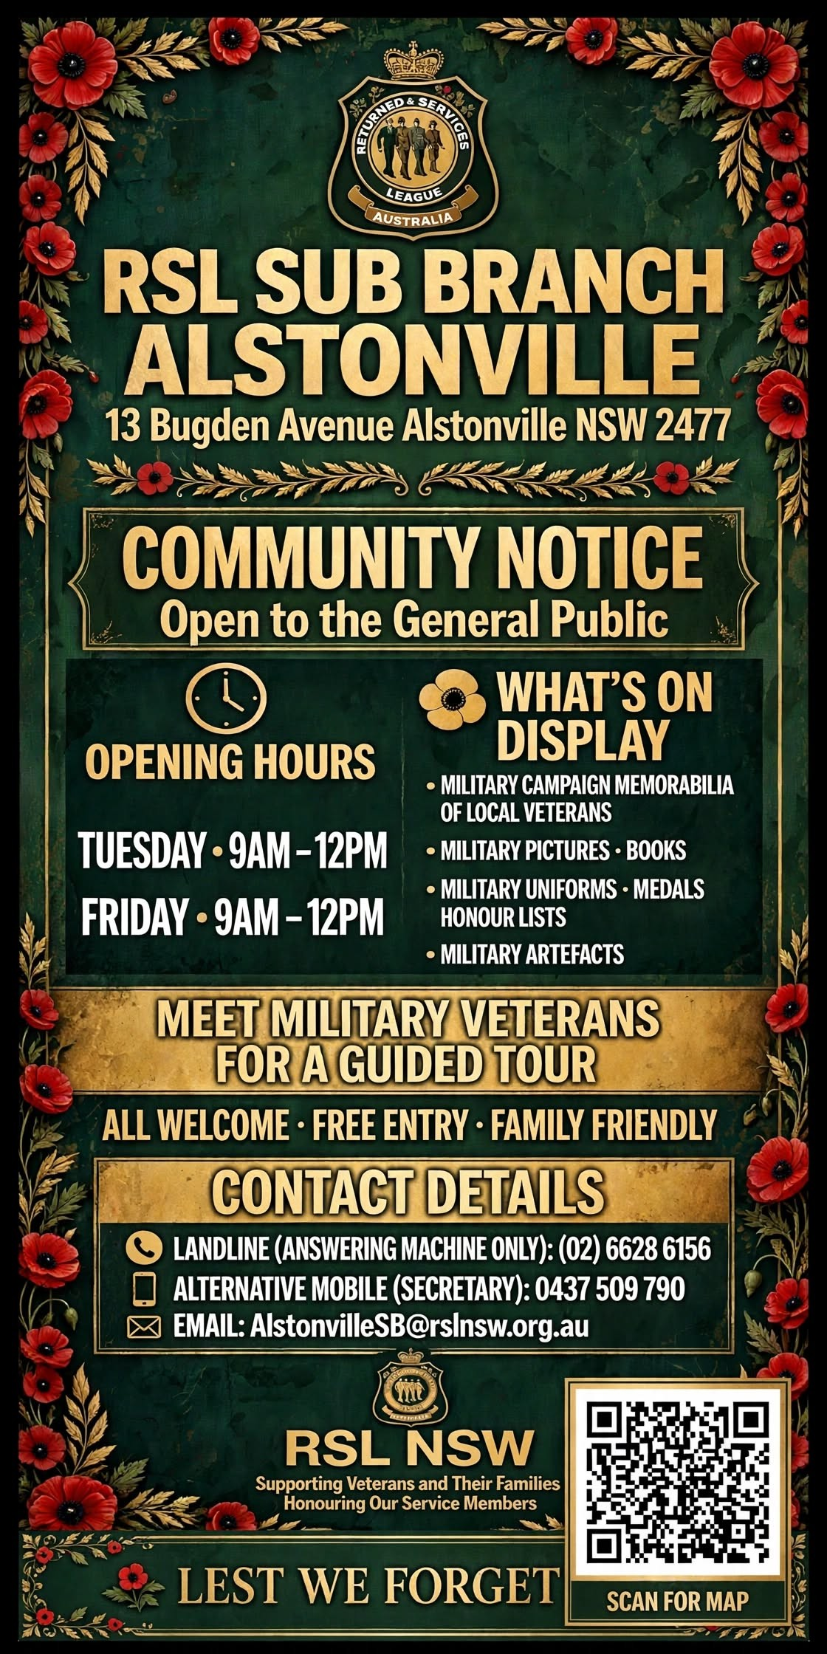

RSL NSW
Help Save Victoria Barracks Sydney
An open letter to all RSL NSW members
August 2026
Dear members
In response to the 2023 Defence Strategic Review, the Australian Government commissioned an independent audit of the Defence estate to ensure it is best positioned to support the nation’s future Defence capability and operational requirements.
The Defence Estate Audit was delivered to Government in December 2023. It recommended a focused program of consolidation and divestment across dozens of Defence sites aimed at rationalising and re-orientating the estate towards contemporary and future security challenges.
The Federal Government announced in February this year its plans to sell off 67 ‘surplus’ military sites nationwide – including the spiritual home of the Australian Army, Victoria Barracks Sydney.
Victoria Barracks at Paddington has stood for more than 180 years. Generations of Australians walked through those gates before they went to war. It is still used by Defence today. If it is sold, it is gone for good.
RSL’s position is that any divestment of Defence estate must be determined by Australia’s current and future strategic and Defence capability needs – not simply financial return – with transparent cost-benefit analysis and genuine consultation with current- and former-serving Australian Defence Force personnel and affected communities before any irreversible sale proceeds.
A Senate committee is looking into the sale of Defence land. It reports on 15 September 2026. There is still time to be heard, but not much.
I am asking you to write to your federal MP to oppose the sale of Victoria Barracks Sydney.
Two things matter. It must be your federal member, not your state MP or your council, because the Barracks belongs to the Commonwealth. And put your home address on it, because that is what proves you are a local.
Members of Parliament count the letters they get. A handful on one subject gets noticed. A dozen gets raised in the party room.
And your letter carries more weight than most. You live in their electorate. You vote in it. You have served. When someone who has worn the uniform writes to an MP about a barracks, it is read differently to anything an organisation can send.
RSL NSW is speaking out on behalf of all veterans. Only you can speak as a local who has served. That is why I am asking.
One request. This is not a party political issue and we must not let it become one. Members of Parliament from every side have spoken out against the sale of the Barracks and we want support from all of them. A calm, respectful letter gets read. An angry one gets filed. Write as yourself, not on behalf of your sub-Branch.
Please tell your sub-Branch Secretary once you have sent it, so we know how many have gone out.
Yours sincerely
Vince Williams, CSC
RSL NSW President
The letter
Fill in the square brackets, then delete the brackets. Post it or email it, whichever suits you. If you are emailing, see page 3.
[YOUR FULL NAME]
[STREET ADDRESS]
[SUBURB STATE POSTCODE]
[PHONE NUMBER]
[EMAIL ADDRESS]

[DATE]
[NAME OF YOUR FEDERAL MP] MP
Member for [ELECTORATE]
[ELECTORATE OFFICE ADDRESS]
[SUBURB STATE POSTCODE]

Dear [MR / MS / DR] [SURNAME]
Please do not sell Victoria Barracks Sydney
I live in your electorate and I am a member of the [NAME] RSL sub-Branch. I am writing to ask you to oppose the sale of Victoria Barracks in Paddington.
[OPTIONAL: I served in the [SERVICE OR UNIT] from [YEAR] to [YEAR]. I have been a member of my sub-Branch for [NUMBER] years.]
In February, the Federal Government announced plans to sell the Barracks in response to an audit of the Defence estate.
I understand money is tight. But this is not spare land. It is not just a building to be sold off.
Victoria Barracks is the spiritual home of the Australian Army. It has stood for more than 180 years. Generations of Australians walked through those gates before they went to war. The Barracks is still in use by Defence today. You cannot put a price on that.
People still serving cannot speak out. That is part of the job. So it falls to those of us who have finished serving to say something. That is why I am writing to you.
There is another way. The Barracks can stay in Commonwealth hands, keep supporting Defence as an operational base, and open up more of its history to the public. Heritage rules put on a buyer are not the same as owning it. Once it is sold, it is gone for good.
I am asking you to do three things:
- say publicly where you stand on selling Victoria Barracks Sydney;
- take it up with the Minister for Defence and the Minister for Finance, who is running the sale; and
- push for the Barracks to be kept, before the Senate committee reports on 15 September 2026.

This is not a partisan political matter and I would welcome your support whichever side you sit on. I would be grateful for a reply telling me where you stand.
Yours sincerely
[YOUR FULL NAME]
Member, [NAME] RSL sub-Branch
Sending it by email

Use this subject line
A local RSL member asking you to save Victoria Barracks
Four things to change
- Leave out the two addresses and the date at the top. Your email does that for you.
- Start at "Dear" and keep the rest as it is.
- Put your full home address under your name at the bottom. Without it the office may not count you as a local.
- Paste the letter into the email itself.
Finding the email address
Your MP's email is on their website and on aph.gov.au. Most look like firstname.surname.mp@aph.gov.au.
If you get stuck
Ask your sub-Branch secretary, or call RSL NSW. We are happy to help you find your MP or work through the letter.

NORTHSTAR EXCAVATIONS SPONSOR OF PORTICO

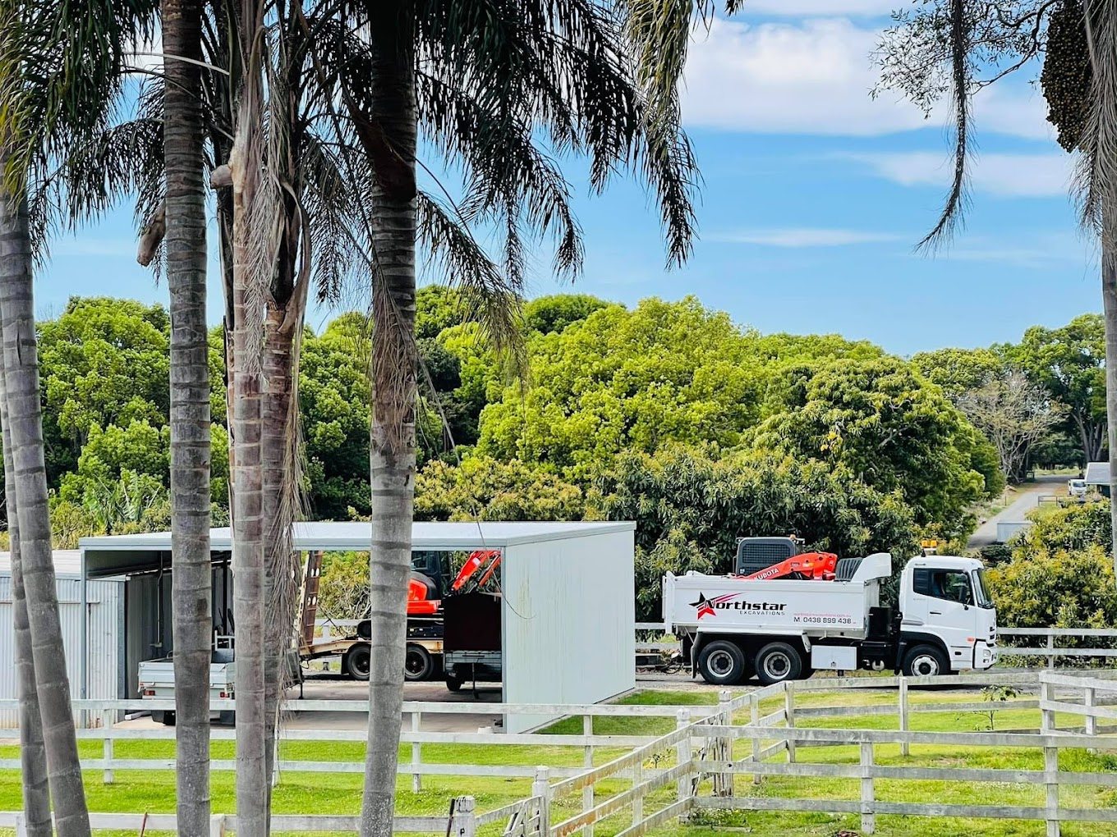

NORTHSTAR EXCAVATIONS is a family-operated business in the Alstonville area. It’s owned by Tyler and Melinda Iverson at 1260 Teven Road, Alstonville NSW.

Melinda and Tyler donated the portico which is at front of our Sub-Branch. Tyler can be contacted on mobile 0438 899 438 for all excavations job. Just mention your are a Sub- Branch member for your discount.

